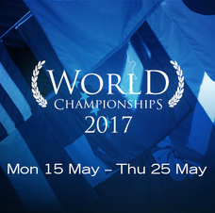
Chers parents,

The Education Perfect World Championships 2017 will take place
from 15 May 3pm - 25 May 3pm 2017.

St Stephen’s School will participate again in the Education Perfect Languages Championships this year. Students can earn points by correctly translating words seen in French class, but at home they also can try different languages. We have launched a competition between the 4 competing classes, may the best class win!!!

The students can also individually win different prizes and certificates and I would like to challenge all students to try to reach at least 500 points to achieve their Credit Award.
The Championships were very popular with our students last year, and I would like to ask you to support your child by cheering them on and allowing a bit of extra screen-time during the Championships. Merci!

All our students from Year 5 and Year 6 are enrolled and use the same password/login as for their normal Education Perfect tasks.

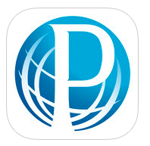
Access www.educationperfect.com or download the free Education Perfect App. Please note that Year 6 students are required to have the updated Education Perfect App on their device. The older version (Language Perfect) may be deleted.

Login: SSSFirstLastname (eg SSSJeanPayot) (login is NOT case-sensitive)
Password: firstname (eg jean)

Très cordialement
Madame Carniello

